NetZero Smart Utility Platform Product Solution Document

1. Introduction
The Smart Utility & NetZero Platform is designed to provide comprehensive monitoring, analytics, and management of utilities such as electricity and water. The platform integrates real-time monitoring, historical data analysis, SCADA visualization, alarm management, billing, and reporting capabilities.
The system aims to support sustainability initiatives by enabling organizations to track energy and water consumption, identify efficiency opportunities, and improve operational performance.

2. Meter Onboarding & Reading Capture

2.1 Overview
The Meter Onboarding & Reading Capture module is responsible for device onboarding, device management, and device data acquisition. It serves as the primary data entry module for the entire platform.
This module ensures that utility meters and IoT devices can be connected to the system, their data captured in real time, and historical records maintained for analytics and reporting.

2.2 Data Points
Data points shall be defined according to project requirements.
Power Meter: kwh, voltage, A, frequency, peak load,
Water Meter: meter reading, battery health status
Gas Meter: meter reading, battery alert

Utilities measuring hardware should have storage capacity to hold a minimum of 1 month of data for all measuring data based on required acquisition rate. The stored data should not be affected by any loss of power supply, network connectivity or server problem. The data should be uploaded and synchronized automatically upon restoration of power and the Platform.

2.3 Supported Communication Protocols
The platform shall support multiple communication protocols to ensure compatibility with various utility metering devices.
Supported protocols include:
lMQTT
lZigbee - Tuya
lWifi - Tuya
lLora
lModbus
lBACnet

2.4 Local Data Storage
The Edge Gateway shall be capable of storing a minimum of one month of utility measurement data locally.
This ensures that no data is lost in the event of network disruptions.

2.5 Data Synchronisation
When connectivity is restored, the platform must automatically synchronise the locally stored data with the central system.

2.6 Virtual Meter
The platform shall support the creation of Virtual Meters.
Virtual meters allow calculated data values based on multiple physical meters or logical aggregation.

Example Use Cases
lTotal Energy Consumption per Floor
lTotal Energy Consumption per Building
lEnergy Consumption in Public Areas

2.7 Appliance Type Tagging
The system shall support Appliance Type Tagging, allowing devices to be categorized according to their usage type.
Example categories include:
lLighting
lPlug Load
lAir Conditioning
lOthers
Allow users to self create tagging catagory
The platform shall provide analytics to break down and analyse energy consumption by appliance category.
Example analysis includes:
lLighting energy consumption
lHVAC energy consumption
This functionality enables users to identify which systems or equipment types contribute the most to overall energy consumption and helps support targeted energy optimization and conservation strategies.

VG Virtual Gateway can onboard all devices from the projects.

2.8 Edge Gateway requirement
Do we need edge gateway? lora gateway? and how are these gateways are set up and part of the solution offer?

state edge gateway model, price, software version, expected no of devices can be paired/run on the edge gateway based on frequency, support protocol

2.9 Device health status check
The Platform shall be able to monitor the hardware health status (i.e. gateway, Utilities measuring hardware, etc) and detect the following:
(a) Communication and connectivity failure (once data are not received/transmitted)
(b) Hardware malfunctioning (through the readings received, e.g stagnant readings over a long period)
Data transmission health check: if device offline, or device online, but data jam such as didn't receive data over a period of time, or receive same set of data continuously?

3. Part 2 — Meter Location

3.1 Overview
The Meter Location module is used to manage the spatial location of devices and establish the relationship between devices and the building spatial structure.

3.2 Hierarchy Data Model
The system shall support a hierarchical location structure including:
lProject
lBlock / Building
lFloor
lRoom
The system shall also record the Gross Floor Area (GFA) of each building and support historical GFA data.

3.3 Hierarchical Data Aggregation
After the hierarchy is defined and devices are bound to locations, the system should automatically aggregate data across different hierarchy levels.

3.4 Global Map View
The platform dashboard shall support a Global Map View displaying:
lProject locations
lProject operational status
lTotal utility consumption
linclude a portfolio summary panel alongside the map
Put dropdown to select project building level room
Reference:
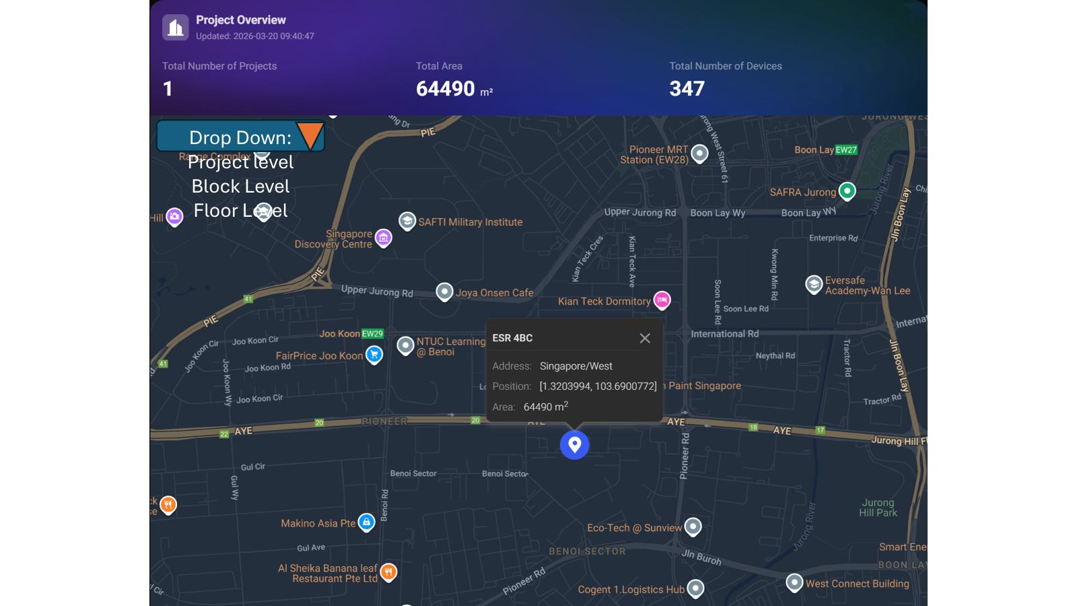
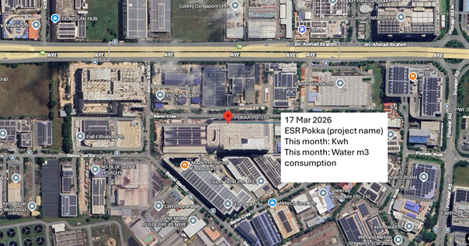
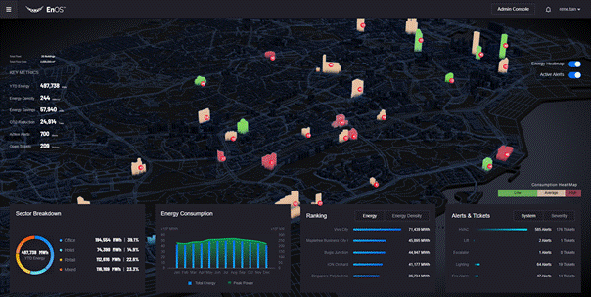

3.5 Hierarchical Navigation
When a user clicks on a project from the global map view, the platform shall zoom into the selected project and display the project-level utility overview.
The interface should include key project information such as:
lProject description
lAddress
lTotal size (e.g., GFA)
Users should be able to navigate through the spatial hierarchy by clicking progressively:
Project → Block → Floor → Room → Device
This enables detailed exploration of utility consumption and monitoring data at each level.

Reference:
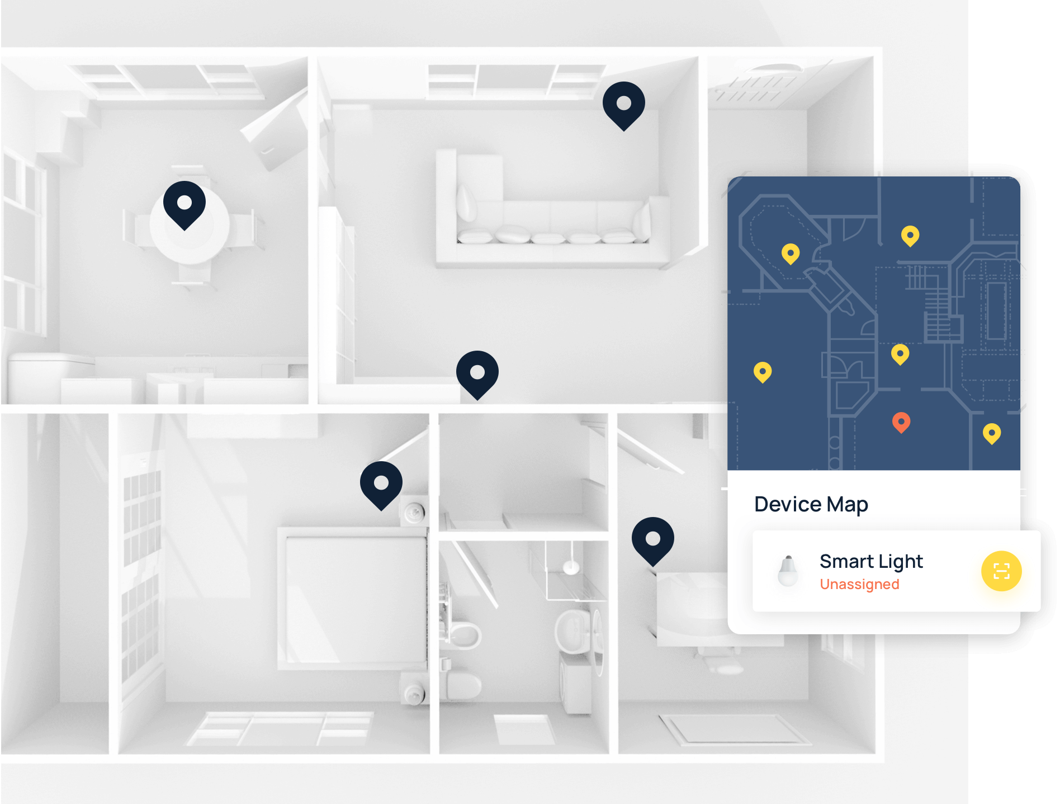
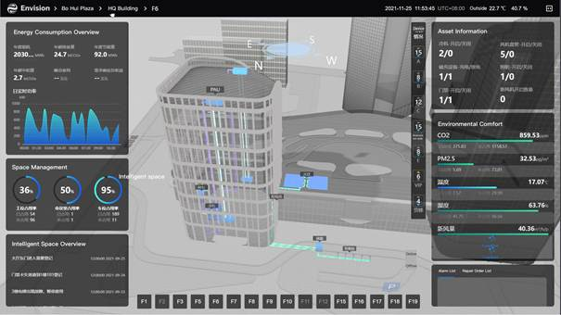

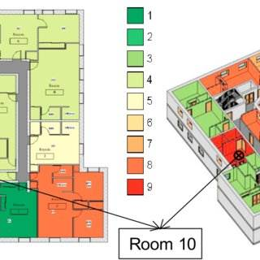
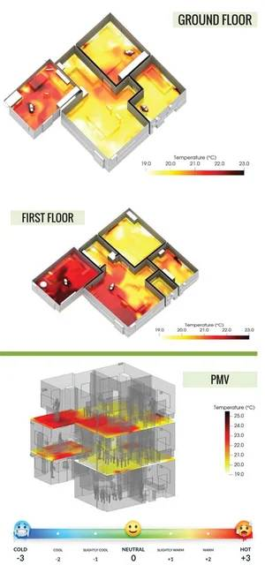
upload PDF, jpeg file, then tag each meter reading on the picture

3.6 Building Map / Floor Map
The platform shall provide building maps and floor maps.
Devices displayed on the map shall include the following information:
lDevice Type
lDevice Status
lConsumption Data

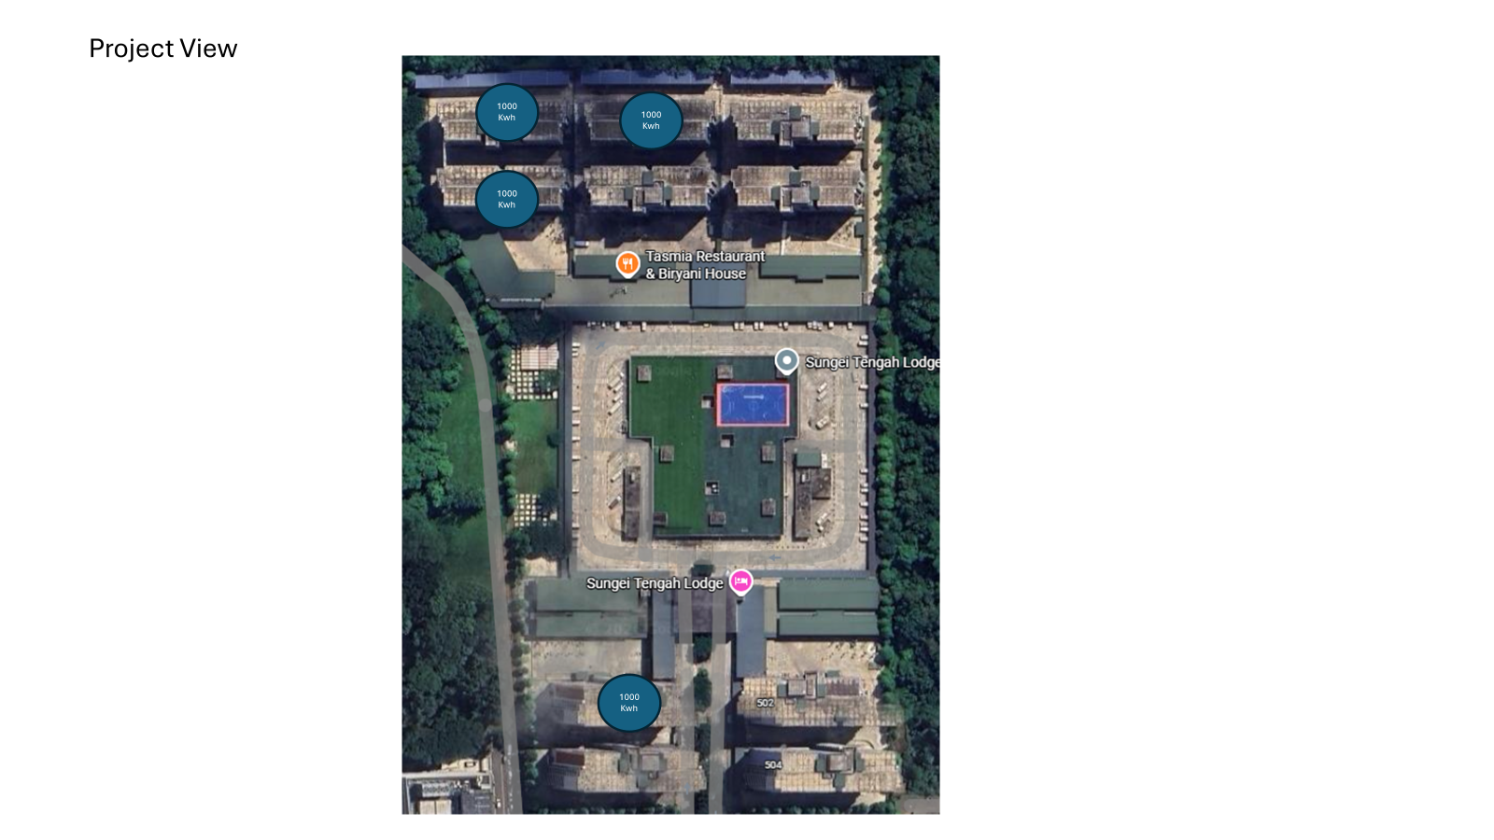
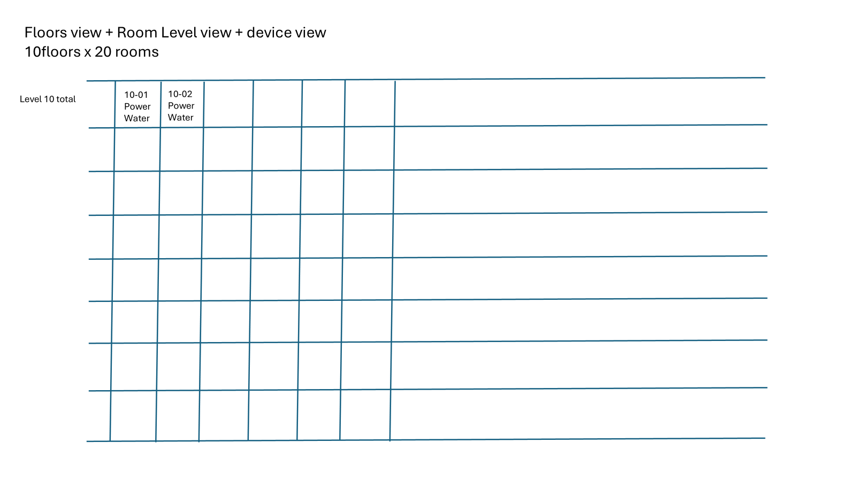
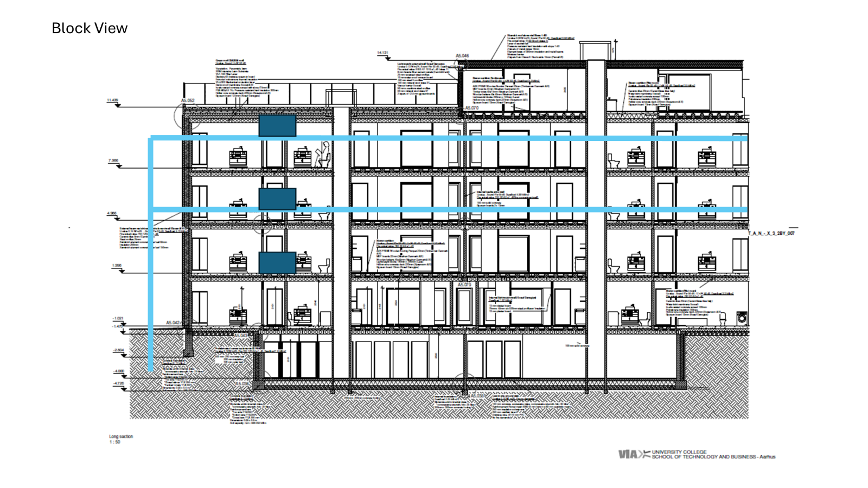
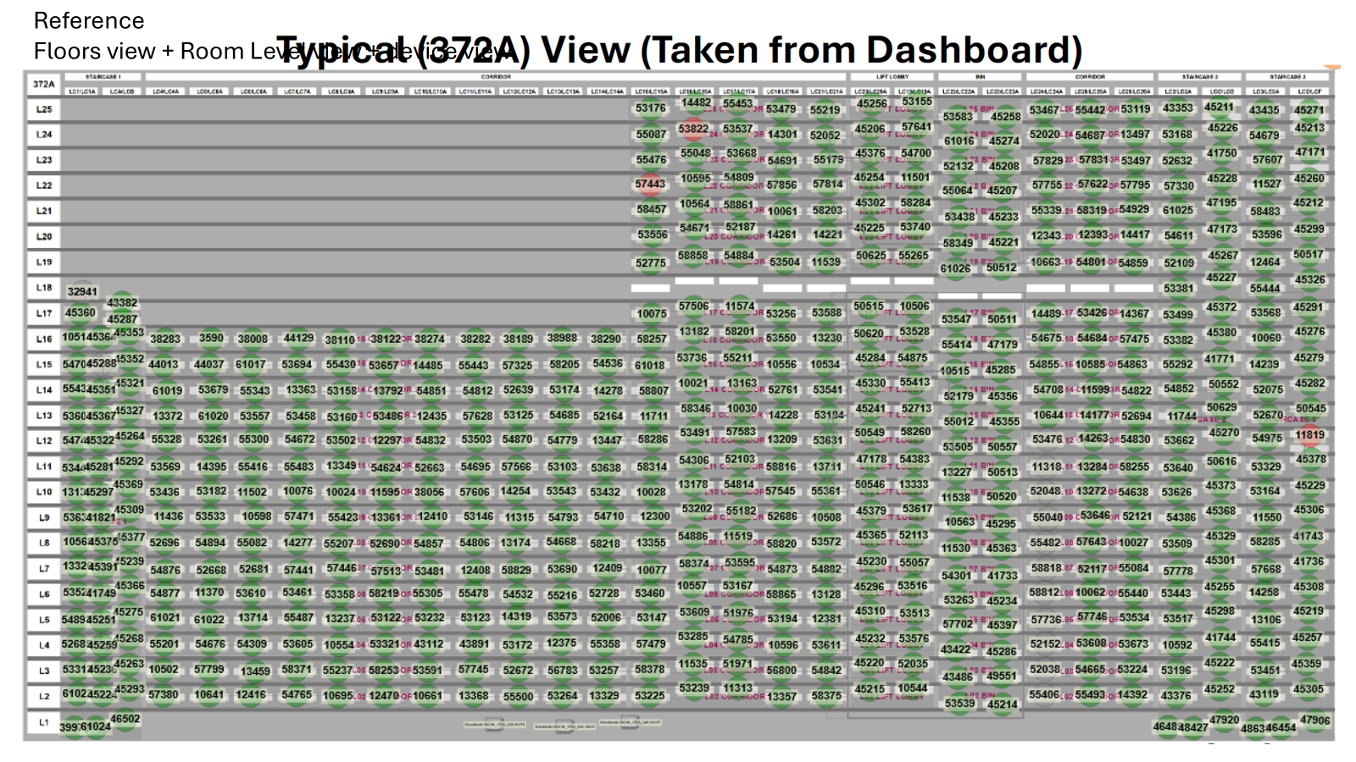
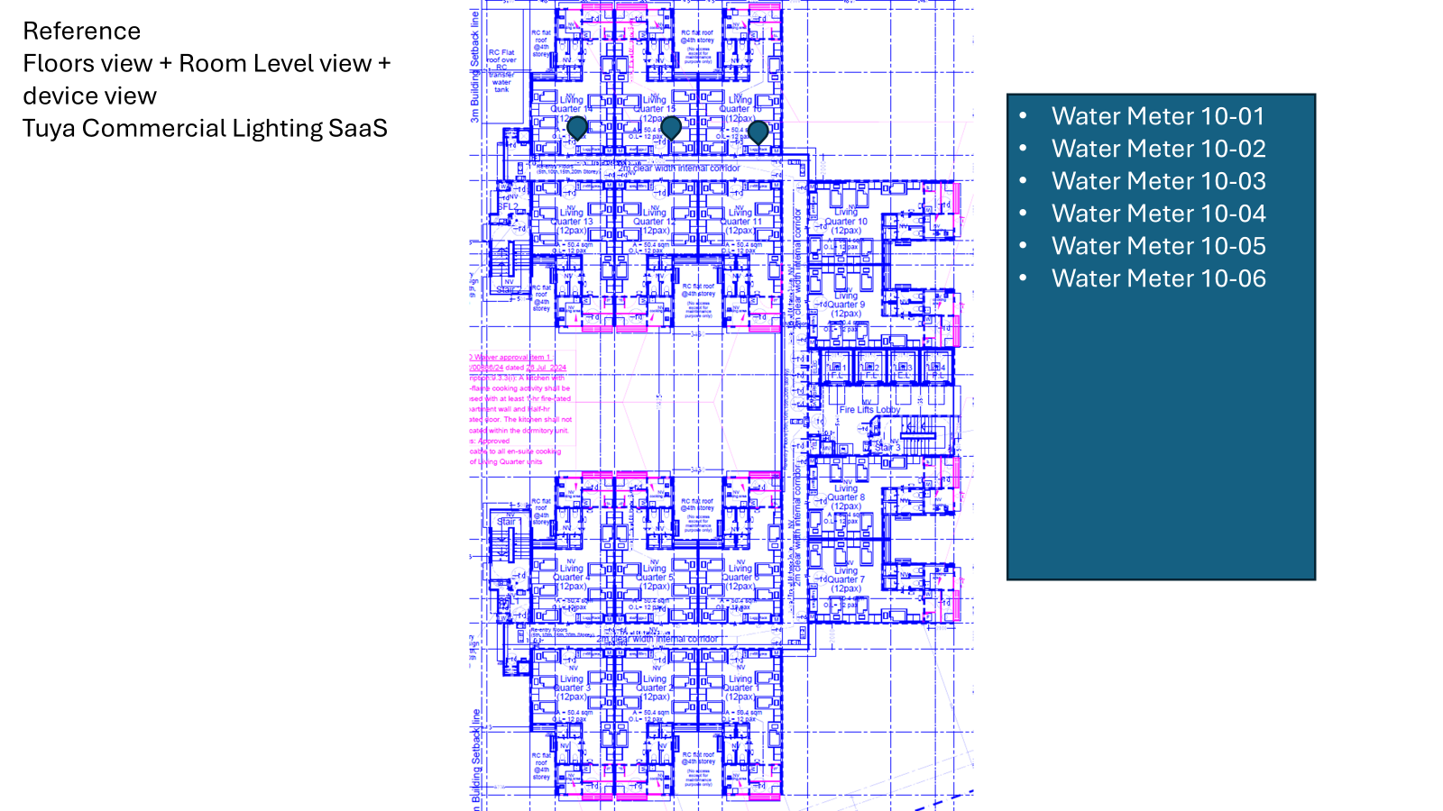

3.7 Device Movement Tracking
The system shall support tracking of device location history in the event that devices are relocated.

4. Part 3 — Data Analysis & Historical Data

4.1 Overview
The Data Analysis & Historical Data module serves as the core analytics component of the platform.
Its primary role is to:
lStore device data
lAggregate data
lAnalyse consumption patterns
lVisualise utility data

4.2 Historical Data Management
The platform must support long-term storage of device data. store 15-min raw data for 2 years then aggregate to hourly for long-term.

Users shall be able to query historical consumption data across multiple time periods.
Supported time granularities include:
lHourly usage
lDaily usage
lMonthly usage
lYearly usage
lCustom period

4.3 Hierarchical Data Aggregation
The system must support hierarchical spatial aggregation using the following structure:
Device → Room → Floor → Block → Project

Historical view: fix project, fix block, fix level, fix room, fix device, show daily, monthly, yearly, custom time period (march to march) for all the years, just need to show KWh, m2 consumption data only

4.4 Utility Usage Analysis
The platform should provide Utilities Analytics to identify opportunities for energy and water savings.
A key analytical function is the Utility Usage Report, which allows users to analyse consumption across multiple time intervals:
lHourly usage
lDaily usage
lMonthly usage

4.5 Utility Ranking
The platform should be able to generate a Utility Ranking Report.
The system shall identify:
lTop energy consumers based on per room, per floor, per block or per building
lTop water consumers based on per room, per floor, per block or per building
Ranking may be calculated based on:
lSpace
lUsage tag
lPer capita consumption requires a place to input the number of people in the room.

based on per room level, generate top ranking abnormal energy consumption ranking based on monthly, with top room in red, slowly go down to orange, then a virtual line as the average, below average will be green

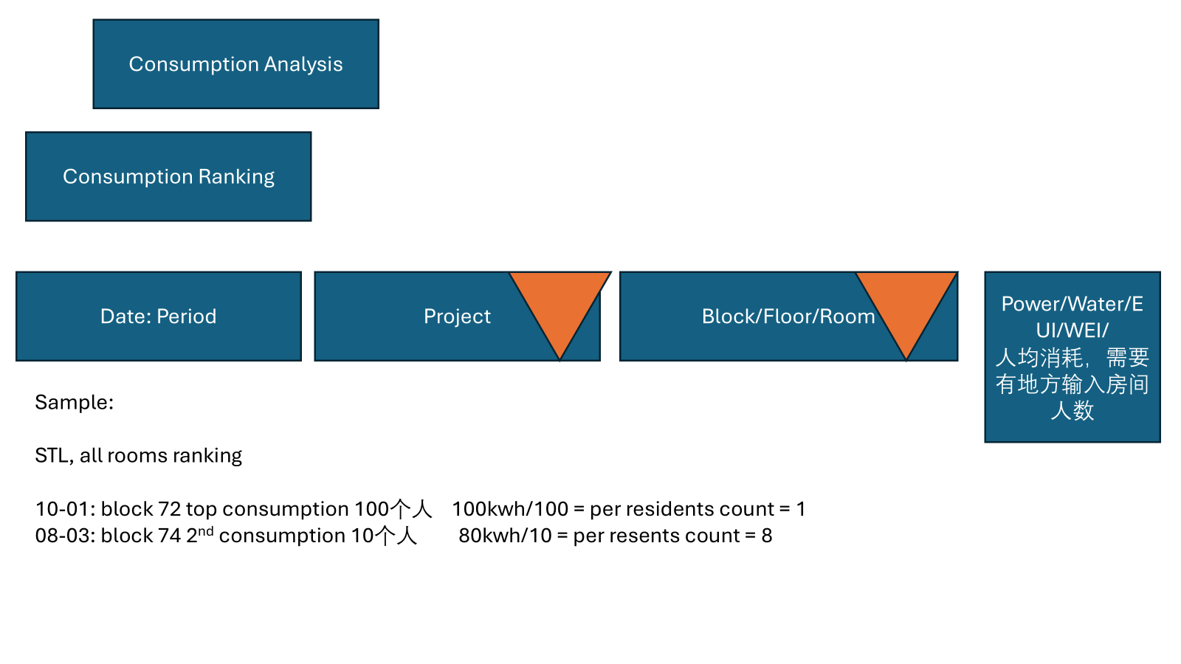

4.6 Consumption Benchmarking （AI）
The platform should support Average Consumption Benchmarking.
Consumption of a specific entity can be compared with benchmark values such as:
lAverage consumption of rooms on the same floor
lAverage consumption of blocks within the same project
lAverage consumption of buildings of the same property type
If consumption significantly exceeds the benchmark, the system should flag the anomaly.
Example:
Room energy consumption is 20% above average.
The platform shall display:
lPercentage difference
lAbnormal consumption indicator

4.7 Energy Saving Recommendation （AI）

Generate energy saving recommendation based on abnormally and findings
maintain a recommendation log that operations teams action.

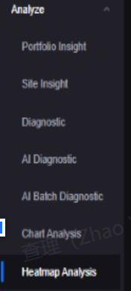

5. Energy and Water Efficiency Index
The platform must calculate building efficiency indicators.

5.1 Energy Utilisation Index (EUI)
EUI measures the energy efficiency of a building.
Formula:
EUI = Energy Consumption / GFA
Unit:
kWh / m²
The system must automatically compute EUI using historical energy consumption data.

5.2 Water Efficiency Index (WEI)
The system must also calculate the Water Efficiency Index (WEI).
Formula:
WEI = Water Consumption / GFA
This metric helps evaluate water efficiency across buildings.

5.3 Historical GFA Support
The platform must maintain historical GFA records.
Example:
2024 GFA = 5000 m²
2025 GFA = 5200 m²The system must apply the correct GFA value when calculating EUI or WEI based on the timestamp of the collected data.

6. Data Visualization
The platform dashboards must support the following visualization types:
lLine charts (trend analysis)
lBar charts (comparison analysis)
lPie charts (distribution analysis)
lHistograms
lHeatmaps
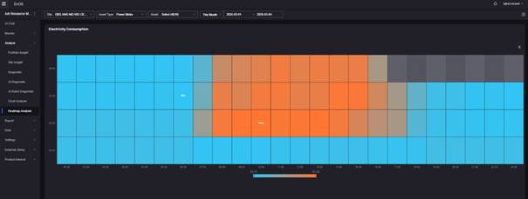
These visualizations may be used to display:
lEnergy consumption trends
lWater usage trends
lComparative consumption across locations
lDistribution of energy usage

The data visualisation dashboards should allow the same charts to include different time series view in days, weeks, months, calendar years and financial years without navigating to a separate chart.

6.1 Data Export
The platform must support exporting analytical data.
Users should be able to export data at:
lDevice level
lRoom level
lFloor level
Supported formats include:
lCSV
lExcel

PDF report export with client logo/branding, scheduled automated report delivery by email on daily/weekly/monthly cadence, API-based export for BI tools such as Power BI and Tableau, and an export audit log showing who exported what and when.

7. SCADA Map View
The SCADA Map View module provides a graphical interface for monitoring utility systems and device status in real time.
This module enables operators to visualize relationships between equipment, meters, and infrastructure through schematic diagrams and map-based views.

7.1 Schematic Diagram
The platform shall support schematic diagrams for both electrical and water systems.
Electrical diagrams shall include single-line diagrams with components such as:
lTransformers
lSwitchboards
lDistribution panels
lCircuit breakers
lEnergy meters
Water diagrams shall align with PUB Water Balance Chart structure and show flow directions.
How to draw these diagram and how to tag each meter reading beside the diagram?
doesn't need to draw Single line diagram, but need to show live data of the meters, need calculation based on sum of the meters, missing reading such as leakage etc
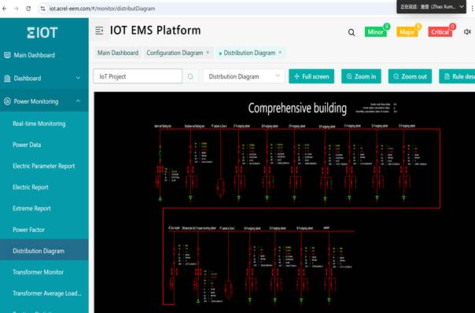
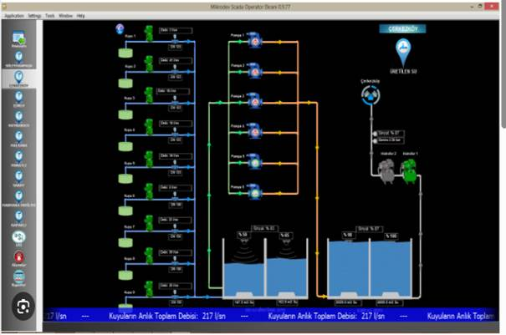
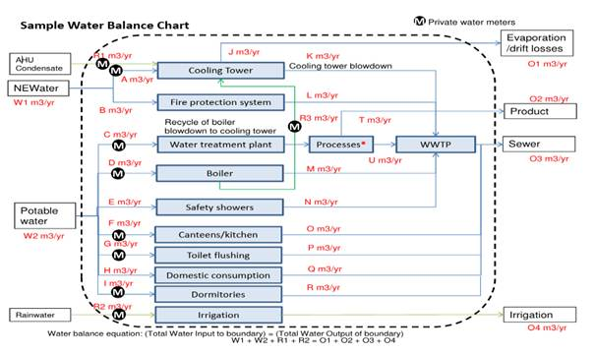

7.2 Device Visualization
Each device shown in the SCADA diagram should display real-time information.

7.3 Interactive Device Navigation
Users should be able to click device icons to access device details.

7.4 Alarm Visualization
SCADA diagrams must display alarm conditions using visual indicators such as:
lColors
lIcons

7.5 Device Health Indicators
SCADA views must display device health conditions based on data transmission health checks.

7.6 SCADA Diagram Editor
The platform should support an editable SCADA diagram interface.
Operators should be able to:
lAdd equipment symbols
lConnect system components
lBind devices to diagram objects
lConfigure data points

Will a custom editor be built or will a licensed library be used such as GoJS or mxGraph/draw.io? A licensed library saves months of development. Also specify: diagram versioning and backup, storage format, and provide the required symbol library list for electrical and water systems upfront.

8. Alert Setting & Alarm Management
This module monitors device conditions and generates alerts when abnormal behaviour is detected.

8.1 Threshold Alerts
The system shall support threshold configuration for each monitoring point.
Threshold alerts are triggered when values exceed predefined limits.
Multiple thresholds per monitoring point must be supported.
Active periods for thresholds must also be configurable.

8.2 Data Anomaly Alerts
The system shall detect abnormal data patterns.
These alerts may be triggered automatically based on analytics or AI modules.
Example deviation thresholds:
l1% deviation
l5% deviation

The Platform should detect data anomalies with machine learning or other Artificial Intelligence (AI) technology based on the utilities data collected.
Data anomaly detection refers to the sudden drastic change in the trending data at a specific time frame, such changes detected could imply possible hardware failure, leakages, or usage abuse of energy and water.

8.3 Alert Hierarchy
Alerts should be supported at different hierarchy levels:
lDevice
lRoom
lFloor
lBlock
lProject

8.4 Alert Notifications
The platform should support multiple notification channels:
lEmail
lSMS
lWeb dashboard notifications

9. Billing & Utility Cost Management
The Billing module calculates utility charges based on meter data and allocates costs according to defined billing models.

9.1 Billing Models
Tenant management
Contract management down to bed level
Cost management for each contract type
Billing cycle

Supported billing models include:
lFull Room Billing
lBed Billing
Client is able to set rate according to specific price,

Add in additional cost if required such as service cost

Customized billing functions build in:
Specific CAG billing models include:
lBed Billing (Pure CE)
lBed Billing (Pure Non-CE)
lBed Billing (Mixed CE and Non-CE)

9.2 CE Contract Billing
Under CE contract terms:
1.The system monitors consumption for three months to establish a baseline.
2.Any excessive consumption beyond the baseline will be billed.
3.A fixed rate of $40 per bill will be applied for excessive consumption.

9.3 Non-CE Contract Billing
Non-CE billing is based on direct consumption.

9.4 Utility Rate History
The system must support historical utility rate management.
All rate changes must be stored with version history.

9.5 Bill format generation
Must be able to generate invoice format based on client logo, address, other key info etc ( can customize for different projects)

10. Reports
The platform shall support generation of system reports.
Required reports include:
lSystem Availability Report
lData Unavailability Report

11. Login & Security
The system must support secure authentication mechanisms.

11.1 Multi-Factor Authentication
The platform should support MFA using:
lEmail OTP

12. Data Integration
The system must provide API for external billing software to retrieve the energy consumption data, such as Xero, accounting software for invoicing and billing requirement

